**"切分器": Is It a Splitter, Segmenter, or Chunker?**

**Overview**

In the rapidly evolving landscape of Artificial Intelligence (AI) and Natural Language Processing (NLP), precise terminology is crucial for clear communication. A foundational concept, especially with the rise of Large Language Models (LLMs) and Retrieval-Augmented Generation (RAG), is the process of breaking down large documents into smaller, manageable pieces. In Chinese, this tool or process is often called "切分器". However, its English translation is not straightforward, leading to a common point of confusion: should we use **splitter**, **segmenter**, or **chunker**?

This essay will dissect these terms, drawing on authoritative sources like academic papers, leading AI vendor documentation, and influential tech blogs to provide a definitive answer for both beginners and seasoned professionals. The short answer is: while the terms are often used interchangeably, they carry distinct nuances.

**"Chunker" is the prevailing and most practical term in modern AI development, "Segmenter" is the more formal and broader academic term, and "Splitter" typically refers to the specific software tool that performs the action.**

**The Core Problem: Why We Need to Divide Text**

Before diving into terminology, let's understand the "why." LLMs, despite their power, have a finite "context window"—a limit on the amount of text they can process at once. Feeding a 100-page document directly into a model like GPT-4 is not feasible. Therefore, we must break it down. This process is a critical preprocessing step for many NLP tasks:

* **Retrieval-Augmented Generation (RAG):** In RAG, documents are broken into pieces, converted into numerical representations (embeddings), and stored in a vector database. When a user asks a question, the system retrieves the most relevant pieces of text to provide context to the LLM for generating an answer.
* **Text Summarization:** Summarizing a long book or report often requires processing it in sections.
* **Information Extraction:** To find specific entities or facts in a large corpus, it's more efficient to work with smaller, targeted sections.

The quality of this division is paramount. Poorly divided text can cut sentences in half, separate related ideas, and ultimately lead to irrelevant search results and nonsensical AI-generated responses. This is why the method of division has become a field of study in itself.

**Dissecting the Terms: A Deep Dive**

Let's examine each term's specific meaning and usage, supported by examples from industry leaders and academia.

**1. Chunker: The Practitioner's Choice**

In the context of modern AI applications, especially those involving LLMs and vector databases, **"chunking"** is the most widely adopted term for the process of breaking down text. A "chunker" is the system or algorithm that performs this task, and the resulting pieces are called "chunks."

Leading AI and vector database companies have standardized on this term.

* **Pinecone**, a premier vector database provider, extensively uses "chunking" in its documentation, defining it as "the process of breaking down large text into smaller segments called chunks" to optimize relevance in a vector database.
* **Microsoft Azure**'s documentation for its AI Search and RAG solutions refers to "Text Chunking" as a key step in the ingestion pipeline.
* **SAP** introduced "Text Chunking" as a new NLP function in its HANA Cloud, highlighting it as an essential preprocessing technique.
* **IBM**'s tutorials on RAG systems also focus on "chunking strategies" as a core component.
* **OpenSearch** documentation explicitly defines "text chunking" as a necessary process for splitting large documents before creating embeddings.

The term has historical roots in NLP as well. The classic **NLTK** library has a nltk.chunk package, though it was traditionally used for "shallow parsing"—identifying phrases like Noun Phrases (e.g., "the big red car"). While the original use case is different, it established the term within the NLP lexicon.

**Illustration: Common Chunking Strategies**  
The term "chunking" is often paired with specific strategies, which highlights its practical nature.

This is the go-to term for developers, data scientists, and anyone building modern AI applications. It is practical, widely understood, and used by major technology vendors.

**2. Segmenter: The Formal & Academic Choice**

**"Segmentation"** is a broader and more formal term. In academic literature, "text segmentation" and "text chunking" are often used as synonyms. However, "segmentation" can refer to dividing text at various levels of granularity, from words (tokenization) and sentences to entire topics. [[14]](https://www.vdu.lt/cris/bitstreams/ec574d52-e463-42a5-8a95-a233f0367175/download)

Authoritative sources demonstrate this formal usage:

* **Academic Papers:** Research papers on platforms like arXiv and MDPI frequently use "text segmentation" when proposing new methods for dividing text based on semantic or topic boundaries.
* **Google Cloud:** Google uses "Text Segmentation" in its Cloud Vision API to describe how it divides an image into chunks of text. More recently, Google AI announced Gemma-APS, a model suite specifically for "text-to-proposition segmentation," a fine-grained form of semantic division.
* **spaCy:** A leading NLP library, spaCy, uses the term "segmenter" for its components that perform sentence boundary detection, such as the SentenceRecognizer. For Chinese, it offers different "segmenter" options for word segmentation.

This term is perfectly correct and often preferred in academic papers, research contexts, or when discussing the theoretical aspects of dividing text. It suggests a more formal, and often more linguistically or semantically informed, process than the general-purpose "chunking."

**3. Splitter: The Tool for the Job**

The word **"splitter"** is the most concrete of the three. It almost always refers to the specific *implementation*, *class*, or *function* that performs the act of chunking or segmentation. It describes the tool, not the process or the concept.

The most prominent example comes from **LangChain**, a popular framework for building LLM applications.

* LangChain provides a variety of TextSplitter classes. Developers use RecursiveCharacterTextSplitter for recursive chunking or SemanticChunker (which, despite its name, inherits from TextSplitter) for semantic splitting. The name makes its function clear: it is a tool that splits text.
* An article on Medium analyzing different methods refers to them as "5 different levels of splitting text," again framing it as the action performed by a tool.
* SAP's documentation also mentions a "Document Splitter" as a specific tool available within its broader "Text Chunking" function.

**Illustration: The Relationship Between Terms**  
This diagram clarifies how the terms relate to one another in a typical RAG workflow.

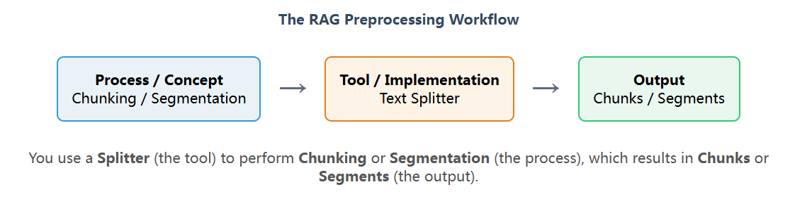Use this term when you are referring to a specific piece of code, a library class, or a function responsible for dividing text. It is the most implementation-focused of the three.

**Conclusion:**

To circle back to the original question about the best term for "切分器," here is a clear guide for every audience:

* **For Industry Practitioners:** Use **"chunker"** and **"chunking."** These terms are the de facto standard in the world of LLM and RAG development. They are practical, unambiguous, and will ensure you are understood by colleagues, in technical blogs, and when reading vendor documentation from leaders like Pinecone, Microsoft, and IBM.
* **For Academic and Formal Discussions:** Use **"segmenter"** and **"segmentation."** These terms carry a more formal, scientific weight. They are appropriate for research papers, theoretical discussions, and when you want to encompass a wider range of text division strategies, from sentence splitting to topic analysis.
* **When Discussing Code and Tools:** Use **"splitter."** When your conversation shifts from the "what" to the "how"—discussing a specific LangChain class or a custom function you wrote—"splitter" is the most precise term for the tool that executes the chunking process.

In essence, you employ a **splitter** to perform the process of **chunking** (in a practical context) or **segmentation** (in a formal context), producing a set of **chunks** or **segments**. By understanding these nuances, you can communicate with greater precision and clarity, marking yourself as a knowledgeable professional in the field of AI.